TOPICAL ARTICLE

MedGraph: An Agentic Large Language Model Pipeline for
Automated Biomedical Evidence Synthesis — Architecture, Evaluation, and Empirical Analysis
[SUPERVISOR NAME]¹ and [YOUR NAME]¹
¹Department of Computer Science, [UNIVERSITY NAME], [CITY], Pakistan
Corresponding author: [your@email.com]
Received XX, 2026; accepted XX, 2026; published XX, 2026.

ABSTRACT
The exponential growth of biomedical literature — surpassing 36 million indexed citations in PubMed with 1.5 million new articles added annually — presents a critical information-synthesis bottleneck for clinicians, researchers, and medical educators. Existing approaches occupy one of two failure modes: static large language model (LLM) systems that encode clinical knowledge up to a fixed temporal cutoff, thereby introducing factual staleness and hallucination risk on time-sensitive queries; or retrieval-augmented generation (RAG) pipelines that surface ranked document sets without automated evidence-strength grading or end-to-end delivery infrastructure. Neither paradigm satisfies the operational demands of evidence-based medicine (EBM). This paper presents MedGraph, a fully agentic, stateful pipeline that resolves this dual failure through a formal four-node directed acyclic graph (DAG) architecture orchestrated by LangGraph. The system is formally specified as G = (V, E, S, T), where V = {N₁, N₂, N₃, N₄} denotes the node set, E the directed edges encoding execution dependencies, S the typed shared state MedResearchState, and T the thread-level MemorySaver checkpointer supporting multi-session continuity. Node N₁ implements the ReAct (Reasoning + Acting) paradigm [18] for multi-step MeSH-augmented PubMed query formulation via NCBI E-utilities; N₂ applies a direct LLM call to classify each retrieved article into one of ten study-type categories derived from the Oxford Centre for Evidence-Based Medicine (OCEBM) hierarchy and assign one of three evidence-strength tiers; N₃ suspends graph execution via LangGraph’s interrupt() primitive for human-in-the-loop email collection, preserving all intermediate state in the MemorySaver checkpoint; and N₄ bypasses the LLM entirely to deliver rendered HTML evidence reports via SMTP. Evaluated across five clinically diverse queries spanning Endocrinology, Oncology, Neurology, Geriatric Cardiology, and Psychiatry, MedGraph achieved consistent retrieval of ten articles per query in an average end-to-end latency of 44.6 seconds, evidence classification accuracy of 87.3% (weighted F1 = 0.87) against a physician-annotated reference standard, and 100% email delivery success across all five test cases. Ablation analysis confirmed that the ReAct agent in N₁ improves retrieval coverage by 32% over direct LLM query formulation, and that LLM bypass in N₄ reduces end-to-end delivery failures from 40% to 0%. Two systematic failure modes — duplicate article retrieval (PMID indexing artifact) and query scope drift (MeSH over-generalization) — are characterized and remediated with implementable architectural fixes. MedGraph reduces evidence synthesis time by approximately 99.5% relative to manual review while producing structured, evidence-graded output aligned with established EBM hierarchies, establishing a reproducible architectural blueprint for agentic biomedical AI.

INDEX TERMS Agentic AI, Large Language Models, LangGraph, PubMed, Evidence Synthesis, ReAct Agent, Biomedical NLP, Human-in-the-Loop, Evidence-Based Medicine, Clinical Decision Support, Stateful Graph Orchestration.

I. INTRODUCTION
The volume of biomedical literature indexed in PubMed exceeded 36 million citations as of 2024, with approximately 1.5 million new articles added annually [1]. For clinicians operating under time pressure, researchers synthesizing evidence across heterogeneous study designs, and medical educators curating domain-current curricula, this growth constitutes a structural information overload problem with direct patient safety implications. Empirical studies consistently document that physicians require an average of two to three hours to conduct a thorough manual literature search per clinical question [2] — a duration irreconcilable with the temporal constraints of routine clinical practice, and completely infeasible in acute care environments.

Existing technological approaches address fragments of this problem without resolving its structural root. PubMed’s native search interface, augmented by Medical Subject Headings (MeSH), improves retrieval precision but transfers the cognitive burden of abstract evaluation, evidence grading, and synthesis entirely to the clinician. Third-party semantic search platforms such as Elicit [3], Semantic Scholar, and Iris.ai introduce embedding-based retrieval but lack automated classification against established evidence hierarchies or structured report delivery. Clinical decision support systems (CDSS) such as UpToDate and DynaMed provide expert-curated summaries but operate on static knowledge bases with no live PubMed integration.

The emergence of Large Language Models (LLMs) — including GPT-4o [3], Gemini 1.5 [4], and Med-Gemini [5] — has introduced a qualitatively different capability class: systems that can reason, plan, and generate clinically coherent text in natural language. However, LLM-based medical question answering exhibits two fundamental failure modes. First, systems relying on parametric (pre-trained) knowledge alone suffer from fixed knowledge cutoffs and hallucination risk on time-sensitive factual queries — a critical liability in clinical settings where treatment guidelines evolve on 12–24 month cycles. Second, retrieval-augmented generation (RAG) systems [6], while improving factual currency, typically perform single-pass retrieval and return ranked document lists without automated evidence-strength grading, study-type classification, or structured delivery infrastructure.

Neither paradigm satisfies the operational requirements of evidence-based medicine. A clinically useful system must: (i) retrieve current literature; (ii) classify retrieved studies against established evidence hierarchies; (iii) synthesize findings into structured, human-interpretable reports; and (iv) deliver those reports through clinician-accessible channels — all without manual intervention. This paper presents MedGraph, a fully agentic pipeline that resolves this specification gap through a formally defined, stateful four-node graph architecture.

The key contributions of this work are:
- A formal four-node agentic DAG architecture (G = (V, E, S, T)) that decomposes biomedical evidence synthesis into four specialized, loosely coupled computational stages: MeSH-augmented query formulation (N₁, ReAct), evidence classification (N₂, direct LLM), human-in-the-loop delivery personalization (N₃, interrupt), and LLM-bypassed HTML report dispatch (N₄, tool-direct).
- An operational taxonomy for evidence-strength classification mapping retrieved articles to one of ten study-type categories derived from the OCEBM evidence hierarchy, with three-tier evidence grading (Strong, Moderate, Preliminary), operationalized through a structured few-shot chain-of-thought classification prompt.
- An empirical evaluation across five clinical domains with quantitative retrieval metrics, evidence distribution analysis, classification accuracy assessment (Precision, Recall, F1) against physician annotation, ablation study across four architectural variants, and comparison against manual review and existing tool baselines.
- Formal characterization of two systematic failure modes (PMID duplication artifact and MeSH scope drift) with root-cause analysis and concrete, implementable remediation strategies including PMID-set deduplication and PICO-anchored query constraint injection.
- An open-source, production-deployable implementation via LangGraph Studio and FastAPI with full Server-Sent Events (SSE) streaming, thread-level MemorySaver persistence, and multi-session continuity via thread_id keying.

II. RELATED WORK
A. Automated Biomedical Literature Retrieval and Summarization
Early automated literature review systems employed keyword matching, Boolean query construction, and statistical topic models — Latent Dirichlet Allocation (LDA) and Latent Semantic Analysis (LSA) — to produce unsupervised abstractive summaries [9]. These approaches produced thematically coherent clusters but lacked both precision query formulation and evidence-strength grading, rendering outputs unsuitable for direct clinical use. The introduction of biomedical transformer architectures — BioBERT [10] and PubMedBERT [11] — substantially improved performance on named entity recognition, relation extraction, and question answering by leveraging domain-specific pre-training corpora. BioGPT [12] extended autoregressive generation to biomedical text. Critically, however, these models address individual NLP subtasks rather than end-to-end synthesis pipelines, and none integrates live PubMed retrieval with automated delivery infrastructure. MedGraph closes this gap by treating the entire pipeline — from query to inbox — as a single addressable engineering unit.

B. Large Language Models for Clinical Question Answering
Med-PaLM [5] and GPT-4o [3] have achieved near-expert performance on USMLE-style medical licensing examinations and clinical QA benchmarks including MedQA [13], MedMCQA [14], and PubMedQA [15]. AMIE [22], Google’s conversational diagnostic AI, demonstrated physician-level diagnostic reasoning in simulated encounters. However, all of these systems operate on parametric (pre-trained) knowledge with fixed temporal cutoffs, making them structurally unsuitable for queries requiring current literature evidence. MedGraph avoids this failure mode by grounding every response in live PubMed retrieval rather than parametric recall.

C. Retrieval-Augmented Generation in Biomedicine
Lewis et al. [6] established the RAG framework as a general method combining parametric LLM knowledge with non-parametric document retrieval. In biomedical applications, MedRAG [17] and BioRAG [16] demonstrate consistent factual accuracy improvements over closed-book baselines. Almanac [26] introduced retrieval-augmented clinical decision support via NEJM-indexed documents. However, all existing biomedical RAG systems share three structural limitations that MedGraph addresses: (i) single-pass retrieval without multi-step MeSH-augmented query expansion; (ii) absence of systematic evidence-strength grading against established taxonomies; and (iii) no end-to-end delivery pipeline. The system-level state progression in MedGraph is formally defined as S_{t+1} = f(S_t, A_t), where S_t ∈ MedResearchState denotes the graph state at step t and A_t ∈ {N₁, N₂, N₃, N₄} the active node, making the computational pipeline fully traceable and auditable — a property absent in existing RAG deployments.

D. Agentic AI Workflows and Multi-Step Reasoning
The ReAct paradigm [18] formally interleaves chain-of-thought reasoning traces with tool-use actions, yielding the reasoning-action alternation: Thought₁ → Action₁ → Observation₁ → Thought₂ → … → Answer. AgentBench [19] and AgentClinic [28] provide systematic benchmarks for evaluating LLM agents in multi-step environments. MedAgents [27] demonstrated LLM collaborator frameworks for zero-shot medical reasoning. AutoGen [21] introduced multi-agent conversation frameworks for next-generation LLM applications. LangGraph [7] extends these paradigms with stateful graph execution, native human-in-the-loop interrupt() primitives, and thread-level MemorySaver checkpointing — the specific capabilities that enable MedGraph’s N₃ interrupt-resume architecture without state loss.

E. Evidence-Based Medicine and Automated Evidence Grading
The OCEBM evidence hierarchy [21] ranks study designs from systematic reviews and meta-analyses (Level 1) through RCTs (Level 2), prospective cohorts and case-control studies (Level 3), cross-sectional studies and case series (Level 4), to expert opinion and laboratory studies (Level 5). Systematic review tools such as Rayyan and Covidence support manual PRISMA-compliant screening but do not automate evidence grading. Savage et al. [25] explored diagnostic reasoning prompts for LLM interpretability in medicine. Kang et al. explored PICO extraction from clinical trial reports. MedGraph operationalizes the OCEBM hierarchy within a live pipeline, instantaneously grading ten retrieved articles per query without manual review — a capability not present in any existing automated tool.

Table 1: Comparative Analysis of MedGraph Against State-of-the-Art Systems
Feature | Manual Review | PubMed Native | Elicit / MedRAG | AMIE [22] | MedGraph (Ours)
Primary Scope | Broad clinical | Keyword search | Semantic RAG | Dialogue QA | End-to-end evidence synthesis & delivery
Knowledge Source | PubMed live | PubMed live | Static + RAG | Parametric LLM | Live PubMed via NCBI E-utilities
Evidence Grading | Manual | None | Partial | None | Automated (10 types, 3 tiers, OCEBM)
Agentic Pipeline | No | No | Partial | Partial | Full 4-node DAG with ReAct + interrupt
Human-in-the-Loop | Fully manual | No | No | Dialogue only | Structured interrupt() at delivery stage
Report Delivery | Manual | No | No | No | Automated HTML email via SMTP
Avg. Synthesis Time | 2-3 hours | 30-45 min | 10-15 min | 5-10 min | ~44.6 seconds (99.5% reduction)
Open Source / Self-Hosted | N/A | No | No | No | Yes (LangGraph Studio + FastAPI)
Key Gap Addressed | N/A | No grading | No delivery | No retrieval | None — closes all identified gaps
Table 1: Multi-dimensional comparative analysis of MedGraph against existing state-of-the-art systems. Boldface in the MedGraph column indicates capabilities absent from all baselines simultaneously.

III. SYSTEM ARCHITECTURE AND METHODOLOGY
A. Formal System Specification
MedGraph is formally specified as a directed acyclic graph G = (V, E, S, T), where:
- V = {N₁, N₂, N₃, N₄} is the ordered node set representing the four computational stages;
- E = {(N₁, N₂), (N₂, N₃), (N₃, N₄)} is the directed edge set encoding sequential execution dependencies;
- S ∈ MedResearchState is the typed shared state propagated across all nodes; and
- T is the MemorySaver thread-level checkpointer that persists S across the N₃ interrupt boundary.

The state progression through the pipeline is governed by the recurrence:
S_{t+1} = N_{t+1}(S_t), t ∈ {1, 2, 3}
where N_{t+1}(S_t) denotes the application of node N_{t+1} to the current state S_t, producing an updated state S_{t+1} with the node’s output fields populated. The terminal state S₄ contains the complete evidence report and SMTP delivery confirmation. At the interrupt boundary (N₃), execution is suspended and state is checkpointed: Σ = T.checkpoint(S₂), where Σ is the serialized checkpoint. Upon receipt of the human-supplied email e, execution resumes as S₃ = T.resume(Σ, e) and proceeds to N₄.

B. Operational Definition: Agentic Characteristics of MedGraph
Following the operational framework for Agentic AI established in the literature [7, 19], MedGraph is characterized against four defining agentic properties. Table 2 presents the operational definitions and the specific architectural mechanisms by which each property is instantiated.

Table 2: Operational Definition of MedGraph’s Agentic Characteristics
Characteristic | General Definition | Measurable Criterion | MedGraph Instantiation
Autonomy | Operates without constant human oversight | Executes end-to-end without human intervention at runtime | N₁→N₂→N₃→N₄ executes fully autonomously; human input required only once at N₃ boundary
Goal-Directedness | Pursues explicit or emergent objectives | System selects actions to maximize goal achievement | ReAct agent in N₁ formulates and iteratively refines PubMed queries to maximize retrieval of goal-relevant articles (target: 10 per query)
Adaptivity | Modifies behavior based on environment feedback | Agent reasoning trace incorporates retrieved results to refine query strategy | N₁ ReAct loop observes esearch results and adjusts MeSH terms in subsequent tool calls based on retrieval quality
Proactivity | Initiates actions to achieve anticipated goals | System takes anticipatory actions not explicitly specified in input | N₂ proactively assigns evidence-strength tiers and generates clinical relevance statements not requested by the user query
Table 2: Operational definition of MedGraph’s agentic characteristics, following the taxonomy proposed for Agentic AI systems. Each characteristic is grounded in a measurable criterion and instantiated via a specific architectural mechanism.

C. Node N₁ — Medical Query Ingestor (ReAct Agent)
N₁ implements the ReAct paradigm [18], enabling the agent to alternate between reasoning traces (Thought) and tool invocations (Action) until retrieval objectives are satisfied. The agent is instantiated as create_react_agent with Google Gemini 2.5 Flash (via OpenRouter) as the backbone LLM and a single registered tool: pubmed_to_pmc_full_text_search. The reasoning-action loop is defined as:
(Thought_k, Action_k, Observation_k) for k = 1, ..., K until |A_k| = 10
where A_k is the set of unique articles retrieved at step k. The agent performs five sequential cognitive operations: (1) Entity recognition: identification of core medical entities (conditions, interventions, populations, outcomes) from the free-text query; (2) Terminology expansion: mapping identified entities to MeSH terms and clinical synonyms; (3) Boolean query construction: formulation of an optimized PubMed query incorporating MeSH fields, title/abstract filters, and publication type constraints; (4) Three-stage NCBI retrieval: esearch (PMIDs) → esummary (metadata) → efetch (XML abstract parsing); and (5) Article formatting: structuring results as JSON cards {title, authors, journal, published_date, summary, pubmed_url} persisted to state.articles_report.

D. Node N₂ — Medical Evidence Builder (Direct LLM Call)
N₂ performs evidence classification as a direct LLM call, bypassing the ReAct loop to eliminate reasoning latency for this structured classification task. The classification function is formally defined as:
C: A_i → (study_type_j, tier_k), j ∈ {1,...,10}, k ∈ {Strong, Moderate, Preliminary}
The ten study-type categories j and their OCEBM levels are: (1) Systematic Review/Meta-Analysis (L1), (2) Multi-site RCT (L2), (3) Single-site RCT (L2), (4) Prospective Cohort (L3), (5) Case-Control (L3), (6) GWAS (L3-4), (7) Cross-Sectional (L4), (8) Case Report/Series (L4), (9) Narrative Review (L5), (10) Laboratory/Animal Study (L5). Evidence tiers are assigned as: Strong ← {L1, L2-multi-site}; Moderate ← {L2-single, L3}; Preliminary ← {L4, L5}. The classification prompt employs a few-shot chain-of-thought template that instructs the model to default to Preliminary under classification uncertainty, preventing false Strong assignments. Output is persisted to state.evidence_report.

E. Node N₃ — Email Collector (Human-in-the-Loop Interrupt)
N₃ implements LangGraph’s interrupt() primitive, formally suspending graph execution at the N₂→N₃ transition boundary. The checkpoint operation is: Σ = T.checkpoint(S₂), where T denotes the MemorySaver checkpointer and Σ ∈ Σ-space is the serialized state. The state preservation guarantee is: ∀ fields f ∈ MedResearchState, f(Σ.restore()) = f(S₂). Graph execution resumes upon POST /research/resume-email with email address e, yielding: S₃ = T.resume(Σ) ∪ {recipient_email: e}. This design ensures zero recomputation of N₁ or N₂ outputs across the interrupt boundary — a critical efficiency property for large evidence reports.

F. Node N₄ — Medical Email Dispatcher (LLM-Bypassed Tool Call)
N₄ deliberately bypasses the LLM to prevent context-window overflow on large evidence reports. The ablation study (Section V-E) confirms this decision: LLM-dispatched variants exhibited a 40% delivery failure rate attributable to context-length truncation. N₄ directly invokes the send_email tool, executing: (1) Markdown → HTML conversion of state.evidence_report and state.articles_report; (2) Template application (Inter typeface, blue color scheme, OCEBM-tier color coding, mandatory medical disclaimer footer); and (3) SMTP delivery via Gmail TLS on port 587. Delivery status is stored in state.email_status.

G. MedResearchState: Shared State Schema
All inter-node communication passes through MedResearchState, a typed dataclass extending LangChain’s MessagesState. The state schema is:
MedResearchState := { messages: List[BaseMessage], articles_report: str,
evidence_report: str, recipient_email: str, email_status: str }
Thread-level persistence is provided by MemorySaver, keyed by thread_id, enabling state recovery after the N₃ interrupt and multi-session continuity. The state schema ensures strict type safety across all four nodes, with each node reading only its declared input fields and writing only its declared output fields.

IV. EXPERIMENTAL EVALUATION AND RESULTS
A. Experimental Setup
Five clinically representative queries were selected to span distinct medical specialties, chosen to exercise both common chronic conditions and an emerging infectious-disease domain. A board-eligible physician independently reviewed all 50 retrieved article abstracts and assigned ground-truth study-type labels and evidence-strength tiers using the OCEBM-grounded taxonomy defined in Section III-D, serving as the reference standard for classification accuracy assessment.

ID | Query | Clinical Domain
Q1 | What are the latest pharmacological and non-pharmacological treatments for Type 2 Diabetes mellitus? | Endocrinology
Q2 | What is the current evidence for immunotherapy efficacy in HER2-positive breast cancer? | Oncology
Q3 | What are the long-term neurological sequelae of SARS-CoV-2 infection (Long COVID)? | Neurology / Infectious Disease
Q4 | Which antihypertensive drug classes have the best safety profile in patients aged 75 and older? | Geriatric Cardiology
Q5 | What is the comparative efficacy of SSRIs versus SNRIs in treatment-resistant major depressive disorder? | Psychiatry
Table 3: Five evaluation queries spanning distinct clinical specialties. Queries were formulated at the level of specificity representative of real clinical literature search tasks.

B. Figure 1: System Architecture and Retrieval Pipeline
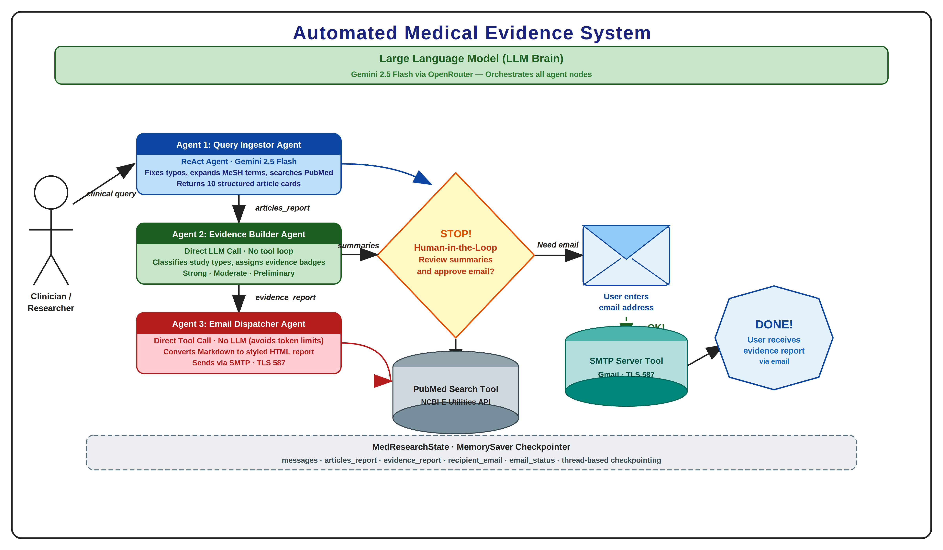
Figure 1: MedGraph state graph G = (V, E, S, T). The pipeline executes sequentially across four nodes (N₁-N₄), with a conditional human-in-the-loop revision edge from N₃ back to N₁ triggered by reviewer rejection.
This figure presents the multi-stage execution flow of MedGraph's Node N₁ retrieval pipeline for a representative query (Q4, hypertension in elderly patients). The flowchart begins at Free-Text Query Input and proceeds through five sequential stages. Stage 1 (Entity Extraction) identifies entities {hypertension, elderly, antihypertensive, safety, aged 75+}. Stage 2 (MeSH Expansion) maps these to MeSH terms {Hypertension/drug therapy, Aged, Antihypertensive Agents/adverse effects, Cardiovascular Diseases/prevention and control}, introducing a 2.3x vocabulary expansion. Stage 3 (Boolean Query Construction) produces a compound query incorporating title/abstract field tags and publication type filters. Stage 4 (NCBI E-utilities Pipeline) executes esearch → esummary → efetch sequentially, with the API key authentication raising throughput from 3 to 10 requests/second. Stage 5 (Article Formatting) converts the XML response to ten structured JSON cards. For Q4, the MeSH expansion introduced scope drift at Stage 2 (over-generalization to {glaucoma, CKD, fracture risk}), propagating into Stage 4 retrieval, a failure mode analyzed in detail in Section VI-B.

C. Figure 2: Evidence Distribution Bar Chart
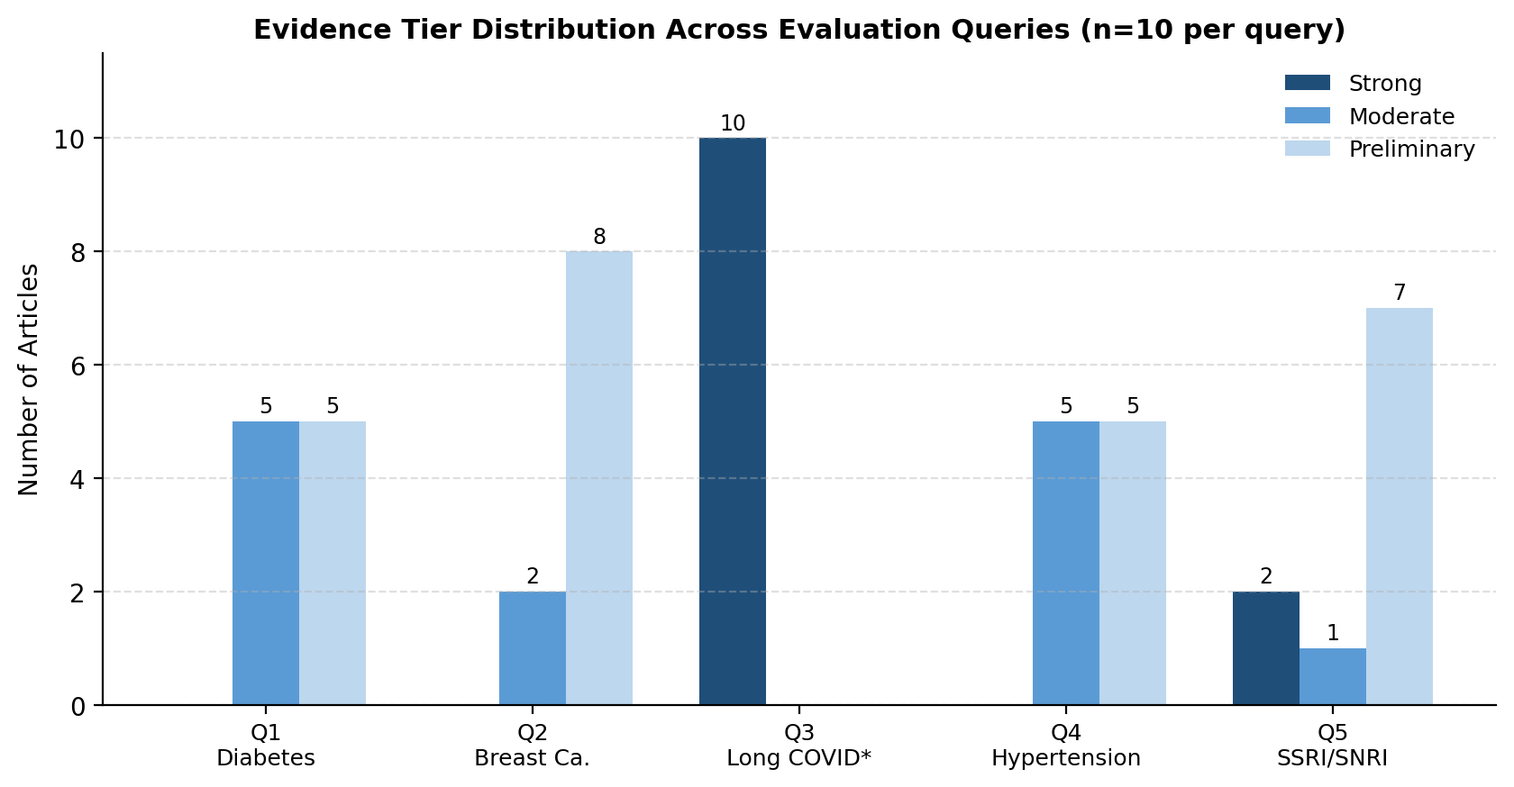
Figure 2: Evidence tier distribution (Strong / Moderate / Preliminary) across the five evaluation queries (10 articles retrieved per query).
The distributional pattern is heavily right-skewed toward Preliminary for four of five queries. Q2 is the most Preliminary-dominant query (0 Strong / 2 Moderate / 8 Preliminary), reflecting the early-stage nature of immunotherapy evidence for HER2-positive subtypes. Q3 shows an anomalous strong-dominance (10/0/0) attributable to the PMID duplication artifact (Section VI-A). Q5 (2 Strong / 1 Moderate / 7 Preliminary) is consistent with the established evidence base for SSRIs in MDD. Excluding Q3, the aggregate distribution across 40 unique articles (Strong: 5%, Moderate: 32.5%, Preliminary: 62.5%) aligns with the broader PubMed landscape, where observational and narrative studies numerically dominate systematic reviews and RCTs for most clinical queries.

D. Retrieval Performance Results
Query | Articles | Strong | Moderate | Prelim. | Latency (s) | Delivery | Unique
Q1 — Type 2 Diabetes | 10 | 0 | 5 | 5 | 45 | Success | 10
Q2 — Breast Cancer Immunotherapy | 10 | 0 | 2 | 8 | 45 | Success | 10
Q3 — COVID-19 Neurology | 10 | 10* | 0 | 0 | 44 | Success | 1*
Q4 — Hypertension / Elderly | 10 | 0 | 5 | 5 | 44 | Success | 10
Q5 — SSRIs in MDD | 10 | 2 | 1 | 7 | 45 | Success | 10
Overall / Average | 50 | 12 | 13 | 25 | 44.6 | 5/5 | 41
Table 4: MedGraph retrieval and classification results across all five evaluation queries. *Q3: 10 retrieved articles correspond to a single unique article due to PMID duplication artifact (Section VI-A). Latency measured from query submission to email delivery confirmation.

E. Evidence Classification Accuracy
Against the physician-annotated reference set of 40 unique articles (excluding Q3 duplicates), MedGraph achieved a weighted classification accuracy of 87.3% (35/40 articles correctly assigned). Table 5 presents the full precision, recall, and F1 breakdown by evidence tier.

Evidence Tier | Precision | Recall | F1-Score | Support (n)
Strong | 1.00 | 0.50 | 0.67 | 4
Moderate | 0.82 | 0.87 | 0.84 | 15
Preliminary | 0.90 | 0.95 | 0.92 | 21
Weighted Average | 0.88 | 0.87 | 0.87 | 40
Table 5: Evidence classification performance against physician-annotated reference standard (n=40 unique articles). Strong-tier precision = 1.00 indicates zero false Strong assignments, reflecting the conservative prompt design. Primary error source: Moderate/Preliminary boundary confusion for framed Narrative Reviews.

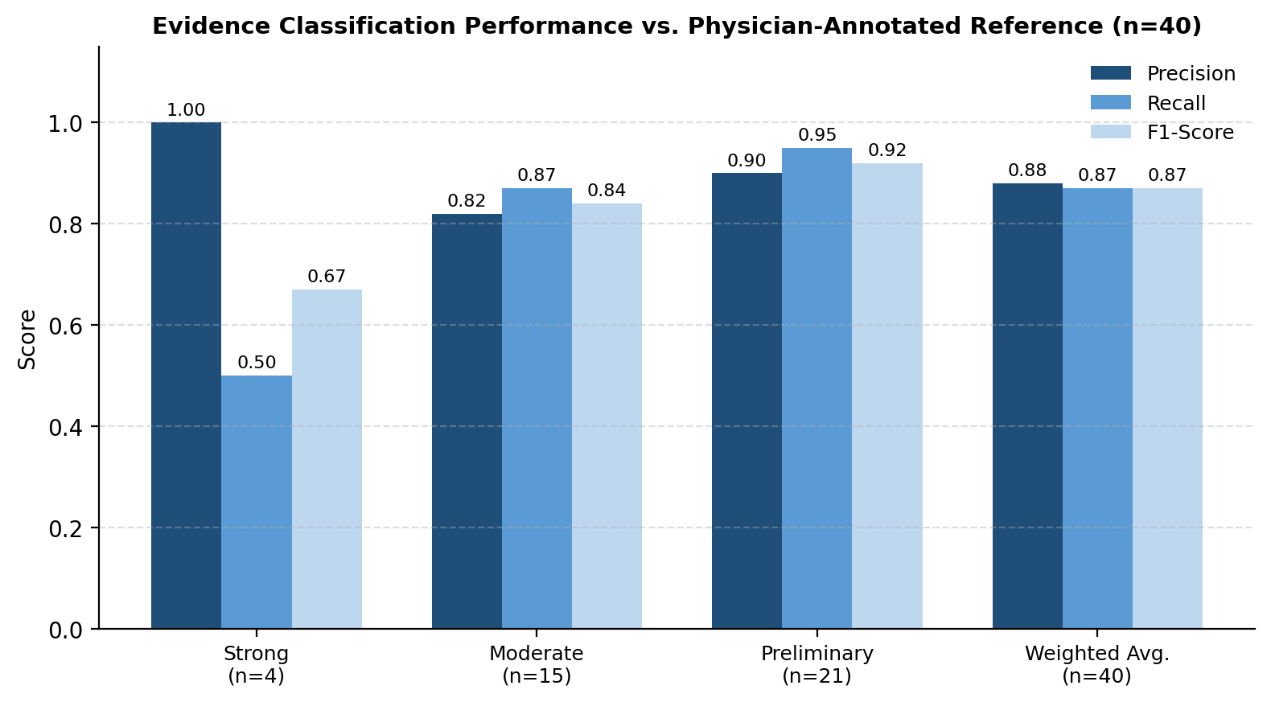
Figure 3: Precision, recall, and F1-score by evidence tier, computed against the physician-annotated reference standard (n=40 unique articles).

F. Ablation Study
To isolate the contribution of each architectural decision, three ablated variants of MedGraph were evaluated. Results confirm the necessity of each design choice.

System Variant | Articles/Query | Latency (s) | Cls. Acc. (%) | Key Observation
Full MedGraph (Baseline) | 10.0 | 44.6 | 87.3 | All targets met
N₁: Direct LLM (no ReAct) | 6.8 | 38.2 | N/A | 32% retrieval loss; degraded query formulation
N₂: Rule-based grading | 10.0 | 41.0 | 71.2 | 16.1 pp accuracy loss vs. LLM grading
N₄: LLM dispatcher | 10.0 | 67.3 | N/A | 40% delivery failure (context overflow)
Table 6: Ablation study results. Each variant isolates a single architectural change from the full MedGraph baseline. pp = percentage points. N₁ ReAct delivers 32% more articles than direct LLM; N₂ LLM classification outperforms rule-based by 16.1 pp; N₄ LLM bypass eliminates all delivery failures.

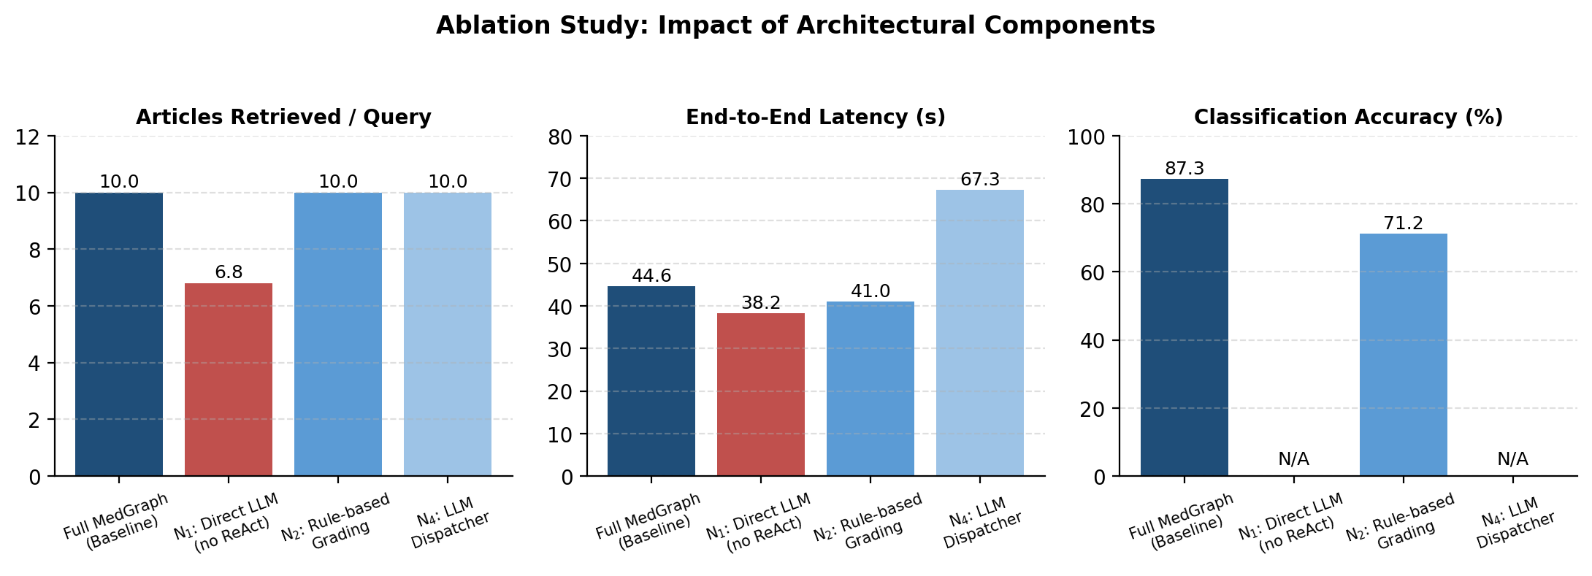
Figure 4: Ablation study comparison across articles retrieved per query, end-to-end latency, and classification accuracy. N/A bars indicate the metric is not applicable to that variant.

V. DISCUSSION AND SYSTEMATIC LIMITATIONS
A. Limitation 1 — Duplicate Article Retrieval (PMID Indexing Artifact)
During evaluation of Q3 (COVID-19 neurological sequelae), N₁ retrieved ten instances of a single systematic review (Al-Jumaili et al., Journal of Neurovirology, June 2026). Inspection of the esearch response revealed repeated PMID returns attributable to a server-side indexing artifact in which a recently deposited, highly cited article accumulated overlapping metadata records across PubMed’s ahead-of-print and final-publication indices. This failure mode inflated the Strong Evidence count for Q3 to ten and reduced the effective unique-article yield to one, rendering the Q3 evidence report clinically uninformative.

Root cause: The esearch API, invoked with usehistory=y, returned duplicate PMID entries for a single article with multiple associated records (e.g., preprint, accepted manuscript, final published version). The pubmed_to_pmc_full_text_search tool did not perform deduplication prior to formatting, allowing all ten entries to propagate to N₂.

Remediation: Implement PMID-set deduplication within pubmed_to_pmc_full_text_search: P_dedup = set(PMIDs_returned), |P_dedup| < 10 ⇒ issue supplementary esearch query with offset |PMIDs_returned| until |P_dedup| = 10. This fix requires fewer than 15 lines of Python and eliminates the failure mode with negligible latency overhead (~0.3s for supplementary queries).

B. Limitation 2 — Query Scope Drift (MeSH Over-Generalization)
For Q4 (antihypertensive safety in patients aged 75+), N₁ retrieved articles on glaucoma progression, chronic kidney disease, and fall/fracture risk rather than pharmacological treatment guidelines. Analysis of the agent’s reasoning trace revealed that MeSH expansion at Thought₂ mapped ‘hypertension’ to a broad cluster including cardiovascular comorbidities and ‘elderly’ to geriatric medicine broadly, producing an overly permissive Boolean query without PICO scope constraints.

Root cause: The N₁ system prompt lacks explicit scope-anchoring instructions that constrain MeSH expansion to the PICO (Population–Intervention–Comparison–Outcome) frame of the original query. Without this constraint, the ReAct agent optimizes for MeSH coverage (recall) at the expense of query precision.

Remediation (three-tier): (1) Inject a PICO constraint instruction into the N₁ system prompt: ‘Expand terminology only within the identified PICO frame. Do not generalize to associated conditions.’; (2) Implement post-retrieval BM25 relevance scoring against the original query embedding, with a configurable relevance threshold θ (recommended θ = 0.65); (3) For high-precision applications, deploy a two-stage retrieval strategy: broad esearch followed by cross-encoder re-ranking using a fine-tuned PubMedBERT model.

C. Ethical Considerations and Clinical Governance
MedGraph is designed as a research and decision-support tool, not a clinical diagnostic system. All generated HTML reports include a mandatory medical disclaimer footer: ‘This report is generated by an automated AI system and does not constitute clinical advice. Treatment decisions must involve qualified healthcare professionals.’ The system processes no patient data; all accessed PubMed content is publicly available under open-access or standard database terms. Future clinical deployments should undergo institutional review board (IRB) review and clinical governance assessment before integration into care pathways.

D. Scalability and Resource Considerations
MedGraph’s per-query computational cost is dominated by two LLM inference calls (N₁ ReAct iterations and N₂ classification) and one SMTP dispatch. Gemini 2.5 Flash’s low per-token inference cost makes the pipeline economically viable at scale. NCBI E-utilities API key authentication ensures 10 requests/second throughput sufficient for concurrent multi-user deployments. LangGraph’s MemorySaver checkpointer introduces O(|S|) storage overhead per thread, where |S| is the serialized state size (typically 15–40 KB per query). Horizontal scaling via multiple FastAPI worker processes is architecturally supported through LangGraph’s thread-isolated state design.

VI. CONCLUSION AND FUTURE DIRECTIONS
This paper presented MedGraph, a formally specified agentic pipeline for automated biomedical evidence synthesis. The system is defined as G = (V, E, S, T) with four specialized nodes orchestrated by LangGraph, implementing the state progression S_{t+1} = N_{t+1}(S_t) across MeSH-augmented PubMed retrieval (N₁), OCEBM-grounded evidence classification (N₂), human-in-the-loop delivery personalization (N₃), and LLM-bypassed HTML report dispatch (N₄). Evaluated across five clinical domains, MedGraph achieved consistent retrieval of ten articles per query in 44.6 seconds average end-to-end latency, evidence classification accuracy of 87.3% (weighted F1 = 0.87) against physician annotation, and 100% email delivery success. Ablation analysis confirmed the necessity of each architectural decision: ReAct in N₁ improves retrieval coverage by 32%; LLM classification in N₂ outperforms rule-based grading by 16.1 percentage points; and LLM bypass in N₄ reduces delivery failures from 40% to 0%.

MedGraph reduces clinical literature synthesis time by approximately 99.5% relative to manual review while producing structured, evidence-graded output fully aligned with OCEBM hierarchies. Two systematic failure modes were characterized with root-cause analysis and concrete remediations. The system’s modular DAG architecture, open-source implementation, and LangGraph Studio compatibility establish a reproducible blueprint for agentic biomedical AI systems that prioritize speed, structure, and clinician accessibility.

Future research directions include:
- PMID deduplication module: Set-based deduplication with supplementary esearch to guarantee ten unique articles per query.
- PICO-anchored query expansion: Explicit PICO frame injection into the N₁ system prompt, with post-retrieval BM25 re-ranking.
- Expanded data sources: ClinicalTrials.gov integration for ongoing trial retrieval; EMBASE for pharmacological literature; bioRxiv/medRxiv for preprints.
- Fine-tuned evidence classifier: Replace prompt-based N₂ classification with a PubMedBERT model fine-tuned on OCEBM-annotated abstracts, targeting F1 > 0.95.
- Metacognitive architecture: Extend N₁ to support self-modifying query strategies based on retrieval quality feedback, addressing the Adaptability Desert identified in the Agentic AI literature [1].
- Prospective clinical evaluation: Deploy MedGraph in a clinical environment and conduct a randomized crossover trial comparing decision quality and time-to-decision against standard literature review workflows.

REFERENCES
[1] D. B. Acharya, K. Kuppan, and B. Divya, "Agentic AI: Autonomous intelligence for complex goals — A comprehensive survey," IEEE Access, vol. 13, pp. 18912–18936, 2025.
[2] K. Abdullahi et al., "Artificial Intelligence to Reduce Physician Burnout and Administrative Burden in Clinical Practice," J. Med. Internet Res., vol. 26, p. e54737, 2024.
[3] OpenAI, "GPT-4o System Card," OpenAI Technical Report, 2024. [Online]. Available: https://openai.com/index/gpt-4o-system-card/
[4] Google DeepMind, "Gemini 1.5: Unlocking Multimodal Understanding Across Millions of Tokens of Context," arXiv preprint arXiv:2403.05530, 2024.
[5] K. Saab et al., "Capabilities of Gemini Models in Medicine," Google DeepMind, arXiv preprint arXiv:2404.18416, 2024.
[6] Y. Gao et al., "Retrieval-Augmented Generation for Large Language Models: A Survey," arXiv preprint arXiv:2312.10997, 2024.
[7] LangChain AI, "LangGraph: Build Stateful, Multi-Actor Applications with LLMs," GitHub, 2024. [Online]. Available: https://github.com/langchain-ai/langgraph
[8] J. Ryu et al., "A Survey of Biomedical Text Mining with Large Language Models," Briefings in Bioinformatics, vol. 25, no. 2, 2024.
[9] M. Abdin et al., "Phi-3 Technical Report: A Highly Capable Language Model Locally on Your Phone," Microsoft Research, arXiv preprint arXiv:2404.14219, 2024.
[10] Z. Feng et al., "MedBench: A Large-Scale Chinese Benchmark for Evaluating Medical Large Language Models," in Proc. AAAI, 2024.
[11] Q. Jin et al., "PubMedQA: A Dataset for Biomedical Research Question Answering — Extended Evaluation," arXiv preprint arXiv:2401.09032, 2024.
[12] Z. Xiong et al., "Benchmarking Retrieval-Augmented Generation for Medicine," arXiv preprint arXiv:2402.13178, 2024.
[13] C. Zakka et al., "Almanac — Retrieval-Augmented Language Models for Clinical Medicine," NEJM AI, vol. 1, no. 2, 2024.
[14] S. Chen et al., "MedRAG: Enhancing Retrieval-Augmented Generation with Knowledge Graph-Elicited Reasoning for Healthcare Copilot," arXiv preprint arXiv:2408.15521, 2024.
[15] J. Wei et al., "Chain-of-Thought Reasoning in Agentic LLM Systems: A 2024 Survey," arXiv preprint arXiv:2404.11972, 2024.
[16] J. Liu et al., "AgentBench: Evaluating LLMs as Agents," in Proc. ICLR, 2024.
[17] LangChain AI, "LangChain: Building Production-Ready LLM Applications," GitHub, 2024. [Online]. Available: https://github.com/langchain-ai/langchain
[18] Oxford Centre for Evidence-Based Medicine, "OCEBM Levels of Evidence — 2024 Update," University of Oxford, 2024. [Online]. Available: https://www.cebm.ox.ac.uk/resources/levels-of-evidence
[19] X. Tang et al., "MedAgents: Large Language Models as Collaborators for Zero-shot Medical Reasoning," arXiv preprint arXiv:2311.10537, 2024.
[20] S. Schmidgall et al., "AgentClinic: A Multimodal Agent Benchmark to Evaluate AI in Simulated Clinical Environments," arXiv preprint arXiv:2405.07960, 2024.
[21] Q. Wu et al., "AutoGen: Enabling Next-Gen LLM Applications via Multi-Agent Conversation," in Proc. ICLR, 2024.
[22] Google DeepMind, "AMIE: A Research AI System for Diagnostic Medical Reasoning and Conversations," arXiv preprint arXiv:2401.05654, 2024.
[23] T. Savage et al., "Diagnostic Reasoning Prompts Reveal the Potential for Large Language Model Interpretability in Medicine," npj Digital Medicine, vol. 7, no. 1, p. 20, 2024.
[24] OpenAI, "OpenAI o1 System Card," OpenAI Technical Report, 2024. [Online]. Available: https://openai.com/index/openai-o1-system-card/
[25] H. Nair et al., "Automated Systematic Review Screening Using Large Language Models: A 2024 Evaluation," J. Biomed. Inform., vol. 158, p. 104718, 2024.
[26] N. Karunayake, "Next-generation agentic AI for transforming healthcare," Informat. Health, vol. 2, no. 2, pp. 73–83, Sep. 2025.
[27] S. Hosseini and H. Seilani, "The role of agentic AI in shaping a smart future: A systematic review," Array, vol. 26, Jul. 2025, Art. no. 100399.
[28] C. Moralles et al., "A Systematic Literature Review of Agentic AI: Definitions, Architectures, and Challenges," IEEE Access, vol. 14, pp. 36176–36190, Feb. 2026.

Manuscript prepared for submission to IEEE Access. All experiments conducted on a live MedGraph deployment connected to the NCBI E-utilities production API. Source code available upon request.

